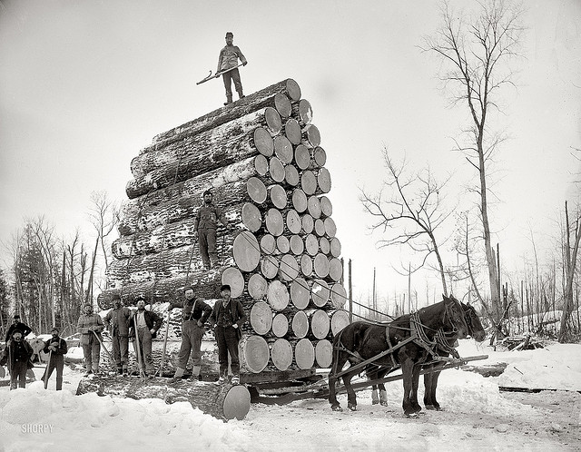
Bigfork Wilderness Days Parade Information

“Biggest Little Logging Town in Minnesota”

Date: Saturday, June 9th 2018

Check in times: Pre-registered entries: 4:15 pm
Unregistered entries: 3:00 pm

Line-up: Line-up will begin north of the Bigfork Hardware Store and continue down Cedar Street. Check in and receive instructions for lining up with the Parade Official located in or near the Bigfork Hardware Store parking lot. If you will be arriving before 3:00pm with a large float or truck please have your driver contact us for instructions. The Parade will end at Kocian’s Family Market parking lot. (Logging Trucks need to exit through Rajala Mill.)
ONLY PRE-REGISTERED FLOATS WILL QUALIFY FOR PRIZES. JUDGING WILL TAKE PLACE BETWEEN 4:15-5:00.

Parade time: 5:00pm
Parade Prizes:

First prize: $100.00
Second prize: $75.00
Third prize: $50.00

Junior Parade (12 years old and under)
Junior Parade Starts First & is NON MOTORIZED
Bring your decorated bike, scooter, skateboard, or walk!
Each participant will receive an award and be entered into a drawing.

Prize winners will be posted promptly following the parade on the bulletin board near the First State Bank of Bigfork.

Contact Bryan Boone (Parade Chair) @ 218-360-9290
Misty Olson (Committee Co-Chair) @ 1-218-910-8923
Email Bigforkwilderness@gmail.com with any questions or concerns.
Wilderness Days Parade Entry Form

Name:
Address:

Brief description of entry:

Preferred method of contact:
Check preference and provide contact information:
Text: My number is:
E-mail: My E-mail address is:
Phone: My phone number is:

Please return applications to the following address or E-mail by May 31st, 2018

Bigfork Wilderness Days Committee
P.O Box 215
Bigfork, MN 56628

BigforkWilderness@gmail.com

Date Entry Received:
(Committee Use Only)

If you are sharing candy or treats, thank you! Remember that items cannot be thrown from vehicles or floats and must be tossed by ground walkers along the parade route.

