BIGFORK WILDERNESS DAY CELEBRATION
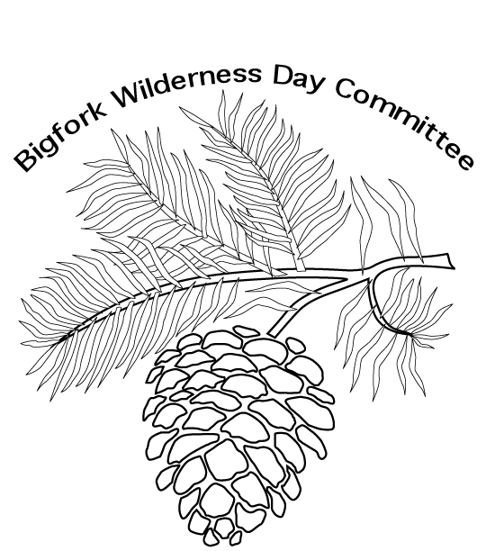
P.O. BOX 215
BIGFORK, MN 56628
Bigforkwilderness@gmail.com
Vendor Registration Form
Deadline: May 21, 2018
Celebration date: JUNE 9, 2018

Business Name:
Owner/Representative Name:

Address:
City: | State:
Zip:
Phone:
Email:
Preferred method of contact: Telephone ____: Text____: Email_____:

Is ELECTRICITY needed? YES |  | NO
How much space is needed? __________________________________________

Provide a brief description of your booth or exhibit: ______________________________________________________________________________________________________________________________________

Non-electric sites are $25.00; Electric sites are $35.00, please include payment with your application. Food Vendors must include a copy of their license.

Please make checks payable to: ”Bigfork Wilderness Days”.
Mailing address: Bigfork Wilderness Days Celebration
P.O. Box 215
Bigfork, MN 56628

Questions??? Please call Misty Olson (Vendor Chair & Committee Co Chair) @: Cell 218-910-8923

Bigfork Wilderness Day Celebration is always the second Saturday of June.
Mark it on your calendar.
“Like” us on Facebook! Bigfork Wilderness Days

